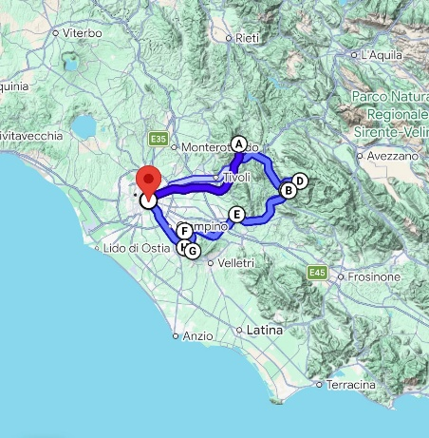
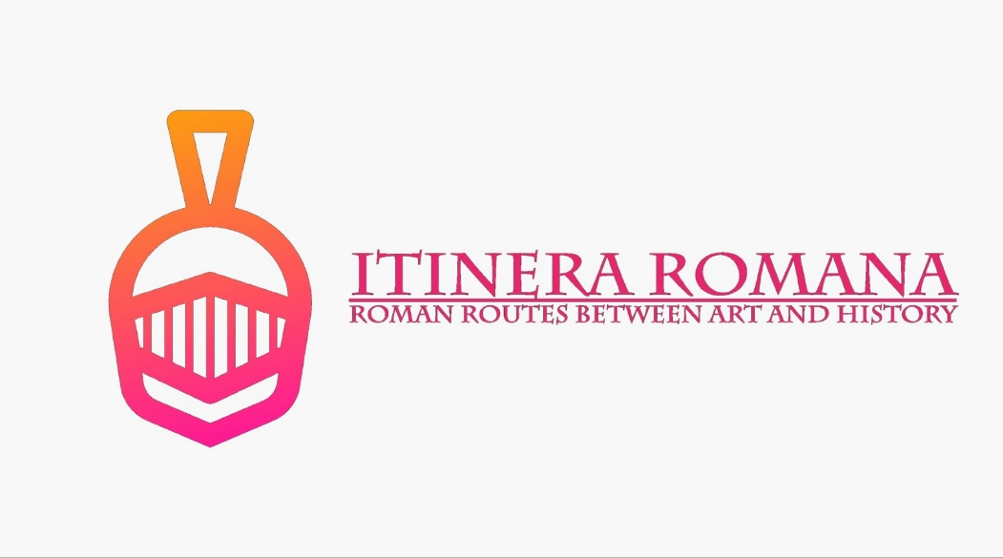
7° Percorso – “Iter Tiberio”

Where: Monti Simbruini
Castelli Romani


How: Car

Time: 5 Hours
Total Trip Time: From 9 up to 10 Hours
Departure: San Giovanni (Metro A)
Arrival: San Giovanni (Metro A)
VS. 2 | English Version | Tickets free | Booking Yes
VS. 2 | English Version | Tickets free | Booking Yes
VS. 2 | English Version | Tickets free | No Booking
- Villa di Orazio
- Sacro Speco di San Benedetto
- Monastero di Santa Scolastica

- Il Cristallo di Neve, Piazzale Campo dell'Osso, 6, 00028 Monte Livata, Subiaco RM

VS. 2 | English Version | Tickets | No Booking
VS. 2 | English Version | Tickets | No Booking
VS. 2 | English Version | Tickets | No Booking
- Museo Archeologico Nazionale Prenestino
- Museo dell'Abbazia greca di San Nilo a Grottaferrata
- Museo delle Navi Romane
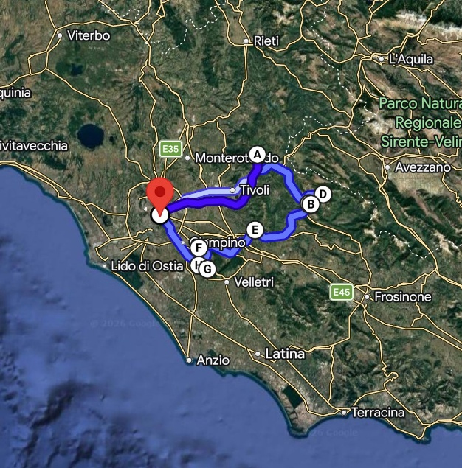
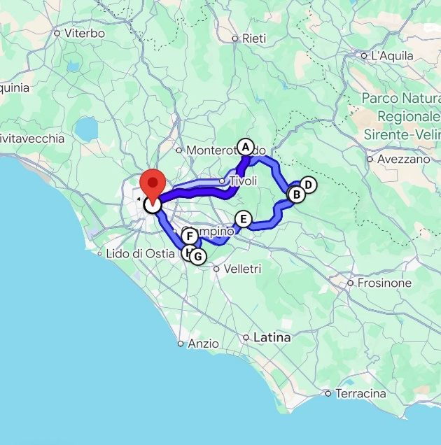
- Le Fratte Ignoranti, Viale Pio XI, 45, 00073 Castel Gandolfo RM

🏛️ Villa di Orazio: Where Poetry Meets Scandal, Intrigue, and a Whole Lot of Trees! 🌿✨
Welcome, dear travelers, history buffs, and poetry lovers! You’re about to step into the world of Horace, one of the greatest Roman poets of all time. But hold on—this isn’t just a boring history lesson. Oh no! This is a tale of Roman emperors, scheming aristocrats, artistic geniuses, shipwrecked paintings, and even a secret literary salon. And all of it takes place in a picturesque countryside retreat surrounded by some of the most Instagrammable landscapes Italy has to offer!

📜 A Villa Fit for a Poet... and Some Unexpected Drama!
The Villa di Orazio sits in the beautiful Aniene Valley, a perfect hideaway for poets, emperors, and anyone trying to escape the Roman heat (and possibly a few political enemies). This very land was once a hotspot for the Roman elite, with summer residences belonging to emperors Hadrian, Nero, Trajan, and senators like Brutus, Cassius, and Cicero.
But here’s the real star: Quintus Horatius Flaccus (or just "Horace" to his friends), who was gifted this villa by none other than Maecenas—the biggest arts patron of the Roman Empire and a close friend of Emperor Augustus. Horace wasn’t your typical rich guy. He loved the simple life, spending his days writing poetry, reading philosophy, and enjoying long walks by the river. Basically, he was the ancient Roman version of someone moving to the countryside to "find themselves" after burnout.

🎭 A Lost Villa, An Accidental Discovery, and Some Very Fancy Trees
For centuries, historians and archaeologists searched high and low for the legendary villa where Horace wrote about “clear waters and a few acres of forest.” But as it turns out, it was hiding in plain sight all along in the charming town of Licenza!
Once the villa was found, the locals wasted no time in turning it into a treasure trove of Roman history. Excavations revealed a luxurious Roman retreat, complete with:
🏛 Two courtyards (because one just isn’t enough for a poet)
🛁 A grand thermal bath complex (even poets need a good soak)
🎨 Intricate mosaic floors and beautiful Roman-style walls
And then, in true aristocratic fashion, along came Alessandro and Julie Bonaparte (yes, those Bonapartes) in the 19th century. Julie, a cultured Parisian socialite, decided the villa needed a literary salon, where artists and intellectuals could debate philosophy under the shade of cypress and oak trees. So what did they do? They landscaped the entire property, following the English-style garden trends, creating a natural paradise for deep thinkers, poets, and probably some very lazy aristocrats.

🎨 The 18th-Century Art Heist (and the Painting That Wasn’t Lost at Sea)
Now, let’s talk about one of the most scandalous art dramas in history. Enter Jacob Phillip Hackert, an 18th-century landscape painter who was OBSESSED with the area around Horace’s villa. He painted ten stunning watercolors of these landscapes, which quickly became the hottest new trend in European art.
But here’s where it gets interesting:
👑 The Queen of Naples bought the paintings as a gift for her sister, Marie Antoinette (yes, the "Let them eat cake" queen).
🚢 But oops—they were supposedly lost in a shipwreck!
🤔 Suspiciously, years later, they turned up in Germany, where they now sit in the Goethe Museum in Düsseldorf.
Even King Gustav III of Sweden got in on the drama, commissioning copies of the paintings to make sure the world didn’t forget how perfectly picturesque Horace’s villa really was.

🌄 The “Ideal View” That Changed European Art
Before Instagram filters, before landscape photography, and before people started painting "moody, dramatic clouds" in every painting, there was the "Ideal View."
🔹 In the 17th century, painters like Poussin and Lorrain thought that the perfect landscape was just "anywhere in the Roman countryside."
🔹 But by the 18th century, Hackert changed the game. He declared that the most aesthetic, perfect, divinely arranged landscape was right here, around Horace’s villa!
Artists, aristocrats, and intellectuals went wild for this new artistic idea. Soon, Grand Tour travelers (young, rich Europeans who roamed Italy to “find themselves”) started making pilgrimages to see Horace’s countryside paradise. Goethe, Winkelmann, Angelika Kauffman, Lord Byron, and even Camille Corot all visited, sketchbook in hand, ready to capture this artistic wonderland.

🤯 From Literary Paradise to Warzone
Of course, no historical site is complete without a little chaos and destruction.
🏴‍☠️ In 1527, the Landsknechts (German mercenaries) stormed through the area during the Sack of Rome. The elegant poetry-filled retreat of Horace? It turned into a warzone.
💣 Later, the Napoleonic Wars and various Italian conflicts shook things up again.
🏰 By the 19th century, the del Gallo family took over and restored what was left.
But through it all, the beauty of the area endured—helped along by artists, poets, and a few determined aristocrats with a passion for history.

✨ Why You Need to Visit Villa di Orazio (Besides Feeling Like an 18th-Century Aristocrat)
🏛 Step into a real-life painting – The views are exactly what inspired European artists for centuries.
📜 Walk in the footsteps of Horace – You’ll be standing where one of Rome’s greatest poets once meditated, read, and wrote.
🎨 Experience the Grand Tour – Feel like an 18th-century traveler discovering the “perfect landscape” for the first time.
🌳 Wander through historic gardens – The trees planted by Bonaparte’s niece are still here, framing Hackert’s beloved views.
📸 The ultimate Instagram spot – Let’s be honest, who wouldn’t want a photo in a place that was literally considered the most beautiful landscape in Europe?

🎟 Ready for Your Own Grand Tour?
So, dear travelers, are you ready to follow in the footsteps of emperors, poets, scandalous aristocrats, and artistic masterminds? The Villa di Orazio is waiting for you. Whether you come for the breathtaking views, the fascinating history, or just to soak in some inspiration, we guarantee that Horace’s peaceful retreat is still as magical today as it was 2,000 years ago.
📍 Location: Mandela, near Tivoli, Italy
🎟 Tickets: Available on-site or online
⏳ Best time to visit: Spring & autumn for the best light (and fewer invading mercenaries)
Come see for yourself why this place has enchanted everyone from ancient Roman poets to scandalous European queens! ✨

🏰 Sanctuary of Sacro Speco: Where History, Mystery, and Swallows Meet! ⛪🕊️
Imagine a monastery clinging to a cliff like a swallows’ nest, suspended between sky and rock, silence and spirituality, art and nature. Welcome to the Monastery of San Benedetto – Sacro Speco, a place so breathtaking that even Pope Pius II, visiting in 1461, couldn’t help but exclaim:
👉 “It looks like a nest of swallows!”
And trust us, if a Pope says it’s cool, it must be something special!
So get ready for an extraordinary journey into a world of medieval frescoes, hidden caves, miraculous stories, and one of the most unique spiritual sites in the world. Oh, and did we mention it also holds the oldest known portrait of Saint Francis of Assisi? 🖼️

🌄 The Cave That Changed the World
Before this monastery became an architectural wonder, before artists covered its walls with stunning frescoes, before pilgrims from all over the world flocked here… it all began with a cave and a young man named Benedict.
🧎‍♂️ The Year: Early 6th Century AD
A young nobleman from Norcia, Benedict, was fed up with the chaos and corruption of Rome. So what did he do? He fled to the mountains, found a small cave in Mount Taleo, and decided to live there as a hermit, following the example of the Desert Fathers.
🥶 The Cave Life: Imagine spending years in total solitude, surrounded by nothing but nature, the wind howling outside, and the occasional visitor bringing food. Sounds extreme? Well, it was! But this spiritual bootcamp transformed Benedict, helping him develop the ideas that would change the course of history.
👉 And what ideas were those? The Benedictine Rule. A simple but powerful way of life based on prayer, work, and community, which would later shape Western monasticism and, well… much of European civilization!

🎨 A Treasure Trove of Art (And a Mysterious Saint Francis!)
Fast forward a few centuries, and the humble cave turned into a magnificent monastery, adorned with frescoes, chapels, and stunning medieval architecture. But the real show-stopper here? The frescoes.
🖌️ Between the 13th and 14th centuries, some of the greatest medieval artists covered the monastery in breathtaking paintings.
🎨 The Most Famous One? The oldest portrait of Saint Francis of Assisi (painted while he was still alive in 1223!). Imagine: Francis, the barefoot, wandering preacher, a real-life celebrity of his time, stopping by to visit this sacred place. And someone decided to capture the moment with a fresco—making this monastery home to one of the most extraordinary pieces of Christian art!

🏗️ How Do You Build a Monastery in a Cliff? (Spoiler: With A LOT of Patience)
The Sacro Speco is not your typical monastery. It’s not a single building, but a series of interconnected structures, all dramatically built into the mountain, giving the impression that they’re growing straight out of the rock itself.
📜 Phase 1: In the late 12th century, the Lower Church was built directly over the cave.
📜 Phase 2: In the mid-14th century, they decided to go even higher, adding the Upper Church.
📜 Phase 3: Over the centuries, smaller chapels and corridors were added, each decorated with more and more frescoes, making this one of the most artistically and spiritually rich monasteries in the world.

🛡️ The Mystery of Saint Benedict’s Seal: A Symbol of Protection
Ever noticed those strange symbols monks and churches sometimes use? Well, San Benedetto has one of the most famous ones: the Seal of Saint Benedict.
🔮 A Powerful Emblem – Found carved into the monastery’s stone walls, the seal is one of the most ancient symbols of protection and exorcism in Christian history.
🚪 Where Can You Find It? – Look for it near the entrance archway and inside, along the staircase leading to the Lower Church.
🙏 Why Is It Important? – Legend has it that this emblem, invented by Saint Benedict himself, has the power to ward off evil spirits and misfortune. (Basically, it’s medieval holy security!)

🏞️ Why Visit the Monastery of San Benedetto?
✔️ A Cave That Changed History – Step inside the very place where Saint Benedict lived and prayed.
✔️ One of the Most Breathtaking Monasteries in the World – Built into a mountain, surrounded by stunning landscapes.
✔️ Mind-Blowing Medieval Frescoes – Including the oldest portrait of Saint Francis of Assisi!
✔️ A Spiritual Oasis – Whether you’re religious or not, the peaceful silence of this place is life-changing.
✔️ Step Into a Fairytale – The monastery looks straight out of a fantasy novel—get ready for some of the most Instagrammable views ever! 📸

So, whether you’re a history buff, an art lover, a spiritual seeker, or just someone looking for an unforgettable experience, the Sanctuary of Sacro Speco is waiting for you.
🌄 Come and discover this hidden jewel in the heart of Italy—just be careful not to disturb the swallows! 🕊️

🏰 The Monastery of Santa Scolastica: A Journey Through Time ⛪📜
Tucked away in the enchanting Sacred Valley, just below the famous Sacro Speco, lies the Monastery of Santa Scolastica—a place that has defied earthquakes, Saracen raids, and centuries of history, standing proudly as one of the oldest Benedictine monasteries in the world.
And guess what? It’s still inhabited by Benedictine monks today! That’s right—if these walls could talk, they’d have more stories than an entire season of historical dramas!

⏳ A Monastery That Refused to Fall
Back in the day, Saint Benedict was on a mission to reshape monastic life, founding fourteen monasteries along his path. The most famous? Monte Cassino, of course. But Santa Scolastica holds a special place in history—it was one of the few monasteries that survived both natural disasters and enemy attacks, while others crumbled.
🔹 Original Name? It was first called San Silvestro Monastery, only taking on the name of Saint Benedict and Saint Scholastica in the 9th century. (Yes, that Saint Scholastica—Benedict’s twin sister!)
🔹 Final Name? The monastery became Santa Scolastica in the 14th century, and the name stuck.
🔹 Golden Era? Between the 11th and 13th centuries, it flourished, becoming a center of culture, faith, and learning.
Santa Scolastica was not just a religious sanctuary—it was also one of the great centers of knowledge in medieval Europe. And speaking of knowledge…

📖 Did You Know? The First Printing Press in Italy Was Here!
Think Gutenberg was the first to print books? Well, almost. While the German inventor gets most of the credit, Italy’s very first printing press was actually set up right here, at Santa Scolastica, in 1465.
📜 Who did it? Two German clerics, Arnold Pannartz and Conrad Sweynheym, brought the revolutionary technology to the monastery, allowing the monks to mass-produce books instead of painstakingly copying them by hand.
📚 The result? The monastery’s library, located on the north side of the Gothic cloister, quickly filled with priceless books and incunabula (early printed books).
So yes—this monastery played a crucial role in the spread of knowledge throughout Italy and Europe. Not bad for a place hidden in the mountains!

🏛 A Treasure Trove of Architecture
What makes Santa Scolastica truly special is the way it combines different architectural styles from different eras, like a living time machine.
✔️ The Entrance: Marked by a beautiful Benedictine motto engraved over the portal:
🛠️ "Ora et Labora" (Pray and Work)—Benedict’s timeless rule for monastic life.
✔️ The Three Cloisters (Yes, Three!)
- The Renaissance Cloister (16th century): Elegant and refined, marking a later addition to the complex.
- The Gothic Cloister (14th century): More austere, reflecting the monastic simplicity of the time.
- The Cosmatesque Cloister (13th century): A masterpiece of medieval craftsmanship, showcasing intricate inlaid marble designs.
✔️ The Bell Tower (12th century): A majestic Romanesque structure, standing tall after centuries.
✔️ The Church (18th century): The most modern part, rebuilt in the Baroque period, blending beautifully with the older parts of the monastery.
Walking through these cloisters is like stepping through different centuries of history, with every stone whispering a story of faith, resilience, and artistic genius.

🏔 A Monastery in the “Sacred Valley”
Santa Scolastica isn’t just about bricks and frescoes—it’s also about the land and the spirit. The valley surrounding it, shaped by centuries of monks and hermits, became known as the Sacred Valley (Valle Santa).
For centuries, this valley has been a place of prayer, meditation, and retreat, attracting pilgrims, scholars, and seekers looking for peace and inspiration.
Even today, as you wander through the silent corridors of Santa Scolastica or admire the surrounding mountains, you can feel the deep sense of spirituality that still lingers in the air.

🤩 Why You Can’t Miss Santa Scolastica!
✔️ One of the oldest Benedictine monasteries in the world!
✔️ A breathtaking mix of medieval, Gothic, and Renaissance architecture!
✔️ Home to Italy’s first-ever printing press!
✔️ Located in the magical Sacred Valley, a place of peace and inspiration!
✔️ Still an active monastery, filled with history and living tradition!
So whether you're a history buff, an architecture lover, a spiritual seeker, or just someone looking for an off-the-beaten-path adventure, Santa Scolastica has something incredible to offer.
🌿 Come discover this hidden gem of the Italian countryside!

🏛 Discover the Ancient Wonders of Praeneste and Gabii! 🏺
Welcome, time travellers! 🎭 Get ready for a journey back in time to explore two of the most important cities of ancient Lazio—Gabii and Praeneste! Older than Rome itself, these cities were once thriving cultural and religious hubs, ruled by powerful divinities and surrounded by stunning landscapes.
Think of it as a blockbuster saga filled with powerful gods, mysterious sanctuaries, fierce battles, and royal intrigues—only with more ruins and fewer CGI effects.

🌿 Gabii: The Lost City of Legends
📍 Where? About 20 km east of Rome, hidden in the untouched Roman countryside.
📜 Founded: Even before Rome, right on the ancient Via Praenestina!
💡 Fun fact: According to Plutarch, Romulus and Remus were educated here—so you could say this is where Rome’s story truly began!
🔹 Gabii was a Big Deal in Ancient Times—it even had its own cult of Juno Gabina, a powerful goddess.
🔹 Excavations have been ongoing since the 18th century, and today, artefacts from Gabii are scattered around the world:
- Some in the Louvre Museum in Paris 🇫🇷
- Some in Rome’s National Roman Museum 🏛
- Some… well, probably still underground waiting to be discovered!

🏰 Praeneste: The City That Became Palestrina
📍 Where? Modern Palestrina, built on the ancient city’s terraces.
📜 Founded: Way before Rome was even a thing (we’re talking at least the 8th century BC).
🏛 Claim to fame? Its massive Sanctuary of Fortuna Primigenia—one of the grandest religious sites in Italy.
🔹 Praeneste’s Forum (now Palestrina’s main square) is an open-air museum. Just walk around, and you’ll be stepping on history!
🔹 The Sanctuary of Fortuna Primigenia was so stunning that Renaissance rulers built a palace on top of it—the Colonna-Barberini Palace, now home to the National Archaeological Museum of Palestrina.
🔹 Inside, you’ll find spectacular artefacts, including:
- Exquisite bronze works (fancy mirrors and intricately engraved caskets).
- Terracotta votive offerings from the Sanctuary of Hercules.
- The legendary "Nile Mosaic", a breathtaking artistic masterpiece depicting the flooding of the Nile in all its exotic glory!

🏛 The National Archaeological Museum of Palestrina
🎟 Where? Inside the Colonna-Barberini Palace, built on the ruins of the Sanctuary of Fortuna Primigenia.
🕰 Time-travel available: Daily, just check the opening hours!
🔹 First Floor: All about the cult of Fortuna Primigenia, featuring colossal statues like the impressive Isis-Fortuna and breathtaking Roman copies of Greek masterpieces.
🔹 Second Floor: A treasure trove of artefacts from tombs and sanctuaries, including:
- Bronze mirrors and caskets with beautiful decorations.
- Votive terracottas showing how deeply the locals worshipped Hercules.
🔹 Third Floor: The star attraction—the Nile Mosaic! 🎨 One of the largest and most important Hellenistic mosaics ever discovered. If you’ve ever wanted to see an ancient Egyptian flood in all its dramatic detail, this is your chance!
🔹 Bonus: Below the museum, you can visit the Criptoportico, a mysterious underground passage originally decorated with stuccoes and filled with sculptures and inscriptions. Spooky and fascinating!

🎭 The Sanctuary of Fortuna Primigenia: Ancient Italy’s Answer to the Parthenon
🌟 What makes it special?
🔹 Built in the 2nd century BC, this massive terraced complex was a masterpiece of Hellenistic architecture.
🔹 Devoted to Fortuna Primigenia, the goddess of fate—basically, the ultimate ancient lottery centre where people came for oracles and divine advice.
🔹 Pilgrims from all over asked the goddess for predictions, using wooden tablets called sortes—the ancient version of pulling a fortune cookie!
👀 What you can still see today:
✔️ Grand staircases and ramps, leading up the terraced sanctuary.
✔️ The Terrazza degli Emicicli, where ceremonies were held.
✔️ The Terrazza della Cortina, where ancient Romans watched religious plays and sacred performances.
✔️ At the very top: The remains of the circular temple that once housed the cult statue of Fortuna—probably covered in gold leaf to shine like the sun!

🏛 The Forum of Praeneste: Where Ancient Romans Did Business & Politics
📍 Location: Right in modern Palestrina’s main square.
🏺 What’s left?
✔️ The Basilica—a grand hall where Romans debated politics and settled lawsuits.
✔️ The Nymphaeum of the Fish (a.k.a. “Antro delle Sorti”)—once a gorgeous water sanctuary decorated with a colourful mosaic of fish and sea creatures. (Unfortunately, it was damaged when it was turned into a lime kiln in the 19th century—ouch!).
✔️ The Treasury (Erario Pubblico)—where all the city’s tax money was stored.
✔️ A portion of the original Forum pavement and even the remains of an ancient Temple of Jupiter, later incorporated into Palestrina’s Cathedral of St. Agapitus.

🏺 A Tale of Conquerors, Emperors, and Aristocrats
Praeneste’s history is full of dramatic twists and turns:
🔹 8th century BC: Founded as a powerful city in ancient Lazio.
🔹 2nd-1st century BC: Its wealth and trade with the eastern Mediterranean made it ridiculously rich—cue massive construction projects like the Sanctuary of Fortuna Primigenia!
🔹 80 BC: Destroyed by the Roman general Sulla after a brutal civil war. Ouch. 😬
🔹 Imperial Rome: Slowly recovered and became a luxury retreat for Rome’s elite—including Emperor Hadrian.
🔹 Medieval times: Taken over by the Colonna family (12th century), then sold to the Barberini in 1630.
And that’s just the highlights—imagine how much more is waiting to be uncovered!

🤩 Why You Can’t Miss This!
✔️ Step into cities older than Rome!
✔️ Visit an epic sanctuary where fate was decided!
✔️ Admire the Nile Mosaic, one of the greatest artworks of the ancient world!
✔️ Discover forgotten ruins in the Roman countryside!
✔️ Feel like an archaeologist exploring real history!
Whether you’re a history buff, an art lover, or just someone who loves epic stories—Praeneste and Gabii are calling your name! Don’t miss the chance to explore these hidden gems of ancient Italy! ✨

🏛 Abbey of St Nilus and Its Hidden Treasures! 📜
Welcome, curious explorers! Get ready for an epic journey through time to one of the most fascinating, mysterious, and historically rich places near Rome—the Abbey of St Nilus in Grottaferrata!
This isn’t just any old monastery—we’re talking about a Byzantine abbey founded over 1,000 years ago, built over the ruins of a Roman villa, home to monks, scholars, warriors, and even a legendary library! And guess what? It's still active today!

🏰 A Fortress, A Monastery, A Time Machine
📍 Where is it? In Grottaferrata, just outside of Rome, nestled in the Castelli Romani hills.
📜 Founded: In 1004 AD by St Nilus, a Greek-Byzantine abbot from Calabria.
🏛 Built on: The ruins of an ancient Roman villa, gifted to the monks by the Counts of Tusculum.
But wait—St Nilus never actually saw the abbey completed! He passed away in 1005, so it was up to his right-hand man, Bartholomew, to finish the job.

🏛 A Fortress of Faith
Unlike your typical peaceful monastery, this place was built like a medieval stronghold—because, let’s face it, the Middle Ages weren’t exactly peaceful!
✔️ Thick defensive walls with battlements and a chemin de ronde (fancy French for “walkway for archers”).
✔️ A semicircular tower, added in 1482 by Cardinal Giuliano della Rovere (later Pope Julius II—yes, the same pope who commissioned Michelangelo’s Sistine Chapel!).
✔️ The Roverian Castle, probably designed by Antonio da Sangallo and Baccio Pontelli. Unfortunately, construction was halted when Giuliano got a big promotion—to Pope!
The entrance once had a drawbridge—because why not? Now, a more modern bridge welcomes visitors into the courtyard, where you’ll find:
✔️ A grand statue of St Nilus—his stern gaze says, "You’d better behave in my monastery!"
✔️ A beautiful portico designed by Sangallo—perfect for some medieval-style contemplation.

⛪ Inside the Church of St Mary of Grottaferrata
🎟 Open to visitors!
✔️ A majestic Romanesque bell tower, towering over the entrance.
✔️ A stunning rose window decorating the façade.
✔️ The "Speciosa" Door, richly decorated with intricate motifs, leading you into a centuries-old spiritual haven.

🎨 A Blend of Romanesque and Baroque
Walking inside, you’ll notice something unexpected. The original Romanesque interior was covered in Baroque stucco decorations in 1754. Imagine an ancient, mystical setting suddenly getting a Baroque makeover—extra, but fabulous!
✔️ Ceiling: The wooden coffered ceiling dates back to 1577.
✔️ Floor: Polychrome marble floors in 13th-century style.
✔️ Triumphal Arch: A 12th-century mosaic depicting the Pentecost, separating the nave from the presbytery.
But wait, there’s more!
📍 Side Aisle:
✔️ The Crypt of Grottaferrata, also called the "Iron Cave"—a mysterious underground sanctuary.
✔️ The Farnese Chapel, featuring frescoes by Domenichino—because every Renaissance chapel needed an artistic glow-up!
📍 The Apse:
✔️ A masterpiece by Bernini—the breathtaking icon of Mary and Child.
✔️ A golden sanctuary, complete with a canopy and a floating silver dove, guarding the Holy Sacrament.

📚 The Legendary Library
This isn’t just any library—it’s a treasure trove of knowledge, with:
✔️ Over 1,000 ancient manuscripts—some dating back to the very foundation of the Abbey!
✔️ More than 50,000 volumes, including some that once belonged to St Nilus himself!
✔️ A world-famous conservation laboratory, where ancient books are restored—including none other than Leonardo da Vinci’s "Atlantic Codex"!
✔️ Manuscripts saved from the 1966 Florence flood—because even priceless history needs a little rescuing sometimes.

🏺 The Museum: A Hidden Archaeological Gem
Deep inside the Abbey, an unexpected treasure awaits—the Museo Archeologico, filled with artifacts that span thousands of years!
🔹 The Collection: Started in 1875, it includes relics gathered by the Basilian monks over the centuries.
🎟 What Can You See?
✔️ A famous ancient stele, depicting a seated youth (5th-6th century BC).
✔️ Marble fragments, coins, pottery, and sarcophagi—because every good museum needs a few ancient tombs.
✔️ Portraits of Alexander the Great & Constantine I—because who doesn’t love a bit of royal flair?
✔️ Islamic and Sicilian ceramics, proving that the Abbey had connections far beyond Italy.
✔️ Rare religious vestments, including the Omophorion—a 14th-century bishop’s silk-and-gold pallium (basically, an ancient VIP robe).
✔️ Frescoes from a nearby medieval church—for that extra artistic touch.
🔹 Bonus Exhibit:
The museum also features a reconstruction of the "Hypogeum of the Garlands", a Roman-era tomb discovered in 2000. Here, archaeologists found:
✔️ Sarcophagi and burials of Aebutia Quarta & T. Carvilinus Gemellus (a father and son duo from imperial times).
✔️ A stunning gold-and-rock-crystal ring—proving that ancient Romans knew how to accessorize.

🔥 Why You Absolutely Must Visit!
✔️ A real-life medieval fortress-monastery—where history, faith, and mystery collide!
✔️ Art by Bernini, Domenichino & Byzantine masters—because who doesn’t love a masterpiece?
✔️ A legendary library—home to Da Vinci’s manuscripts & 1,000-year-old books!
✔️ An underground crypt & ancient tombs—perfect for those who love a bit of mystery.
✔️ A hidden archaeological museum—with artifacts spanning thousands of years!
If you’re looking for a unique, off-the-beaten-path adventure that blends art, history, archaeology, and mystery, the Abbey of St Nilus is an unmissable stop on your Roman journey!
🚀 Ready to travel through 1,000 years of history? Let’s go! ✨

🚢 The Museum of Roman Ships – A Journey Through Ancient Engineering Wonders!
Ahoy, history lovers! 🚢 Imagine discovering two enormous, lavish floating palaces built by none other than Emperor Caligula, the infamous Roman ruler known for his eccentricity and grandeur. Sounds like something out of a movie, right? Well, welcome to the Museum of Roman Ships in Nemi, a place where history, mystery, and tragedy collide!

🏛 The Museum – A Monument to Lost Masterpieces
🏗 Designed by: Architect Vittorio Ballio Morpurgo (for free—now that’s dedication!)
🛠 Built between: 1933 and 1939
📍 Located in: Nemi, near the beautiful Castelli Romani region
🏺 Main Attractions: The remains of two enormous Roman ships from the 1st century AD
The museum was custom-built to house the gigantic ships of Emperor Caligula, which had been lying at the bottom of Lake Nemi for nearly 2,000 years before being recovered between 1929 and 1932. But why were these ships built in the first place? And why did they end up at the bottom of the lake? Buckle up—we’re about to dive into an ancient mystery!

🚢 Caligula’s Mysterious Floating Palaces
The two ships of Lake Nemi weren’t just regular boats. They were floating luxury villas, decked out with marble floors, intricate mosaics, heating systems, running water, and even rotating statues. One of them was a pleasure barge, while the other was a floating temple dedicated to the Egyptian goddess Isis.
But why would Caligula, one of the most power-hungry emperors of Rome, create such extravagant ships?
1️⃣ Pleasure & Power: Caligula, being the extravagant ruler he was, loved to party in style. These ships were floating pleasure palaces, perfect for hosting wild feasts, political meetings, and who knows what else! 🍷🎶
2️⃣ Religious Worship: The second ship was a temple dedicated to Isis, used for rituals and ceremonies to ensure safe travels and prosperity.
3️⃣ Insane Engineering: These weren’t just big boats—they were technological marvels centuries ahead of their time! They had anchors like modern ships, advanced plumbing systems, and even ball bearings to rotate statues!

🔥 A Tragic End – The Damnatio Memoriae & The Fire of 1944
But like all great things, the glory of Caligula’s ships was short-lived. After the emperor was assassinated in 41 AD, his enemies wanted to erase his memory from history (a process called damnatio memoriae). So, what did they do?
💀 They sank the ships. Right to the bottom of Lake Nemi, as if they had never existed.
For centuries, people whispered about the legend of Caligula’s sunken ships, but it wasn’t until the Fascist era in Italy (1929-1932) that Mussolini ordered the lake to be partially drained, finally revealing these lost Roman treasures to the world.
But just when we thought the ships were safe… disaster struck again.
🚨 May 31, 1944: During World War II, a fire mysteriously engulfed the museum, destroying both ships completely. Some say it was bombing damage, others say it was arson by retreating Nazi forces—we may never know the full truth.
All that remains today are scattered relics, charred timbers, and a handful of artifacts, carefully preserved and displayed inside the museum. But even from these fragments, you can feel the grandeur of what once was!

🖼 What Can You See at the Museum Today?
Even though the original ships were lost, the Museum of Roman Ships remains a must-visit for history buffs and engineering enthusiasts.
🚢 Ship Artifacts & Reconstructions: See the anchors, nails, bronze decorations, and intricate wooden planks that made up these floating palaces.
🏛 Roman Engineering Marvels: Discover how Roman naval technology was far ahead of its time.
⚔️ Exhibits on Ancient Naval Warfare & Religion: Learn about the rituals, ceremonies, and political significance behind these ships.
🏺 Artifacts from the Castelli Romani Area: The museum also houses relics from the Sanctuary of Diana Nemorensis, an ancient temple dedicated to the goddess Diana, just a short walk away!
After years of restoration, the museum officially reopened to the public in 1953 and was fully renovated in 2001 to offer visitors a modern, immersive experience.

🌿 Castelli Romani – A Region of History, Wine, and Natural Beauty
If you’re visiting the Museum of Roman Ships, you’re already in one of the most beautiful regions in Italy—the Castelli Romani!
📍 What is Castelli Romani?
A stunning area south-east of Rome, famous for its volcanic lakes, ancient towns, and amazing food & wine.
🌍 Highlights of the Region:
🍷 Frascati – The "City of Wine," home to incredible vineyards and villas.
🐷 Ariccia – Famous for its PGI Porchetta, an irresistible roast pork delicacy!
🌊 Castel Gandolfo – The summer residence of the Pope, with breathtaking views of Lake Albano.
🌸 Nemi – A picturesque village overlooking Lake Nemi, known for its tiny, delicious strawberries.
🏛 Tusculum – Ruins of an ancient Latin-Roman city, where you can explore the remains of a theater, forum, and ancient streets.

🚀 Why You MUST Visit the Museum of Roman Ships
✅ See what remains of Caligula’s legendary floating palaces
✅ Discover how Romans engineered ships ahead of their time
✅ Explore ancient naval warfare, rituals, and luxury lifestyles
✅ Combine history with a day trip to the stunning Castelli Romani region
✅ Enjoy wine, porchetta, and nature while reliving history!

🚢 FINAL CALL – Step Aboard History!
Visiting the Museum of Roman Ships is like stepping into a time machine—a chance to experience the engineering genius, extravagant lifestyle, and dramatic downfall of one of history’s most controversial emperors!
So what are you waiting for? Hoist the sails and embark on this incredible journey! 🏛⛵✨

